Project Development Phase
Model Performance Test

Date | 27 February 2026
Team ID | LTVIP2026TMIDS89777
Project Name | ToyCraft Tales: Tableau's Vision into Toy Manufacturer Data
Maximum Marks | 4

Model Performance Testing:
Project team shall fill the following information in model performance testing template.
S.No. | Parameter | Screenshot / Values
 | Data Rendered | 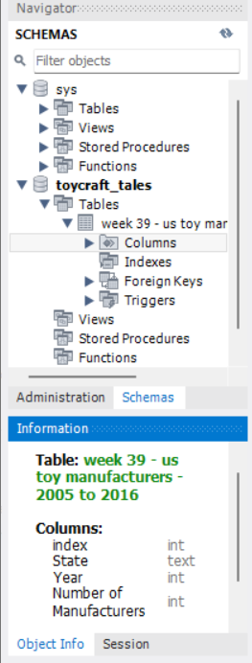  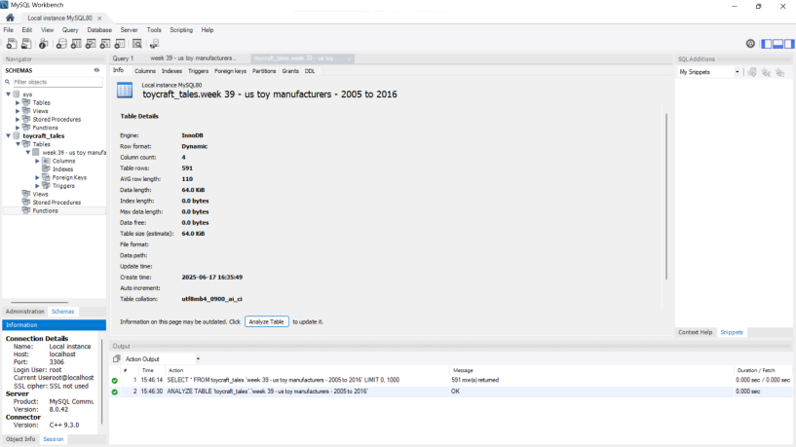
 | Data Preprocessing | No any Preprocessing Required.
3. | Utilization of Filters | 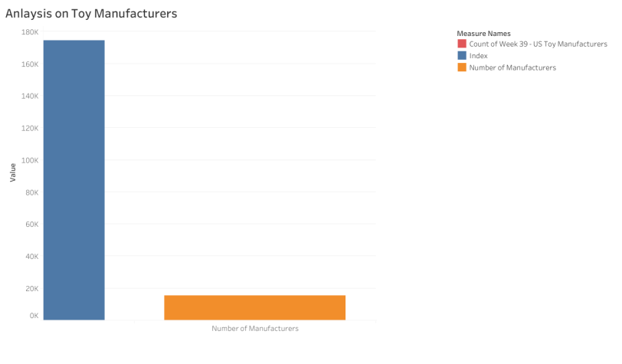  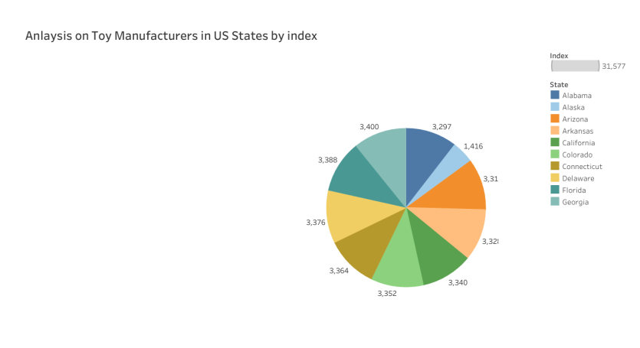  Some of the utilization of filter as year is used here.
4. | Calculation fields Used | 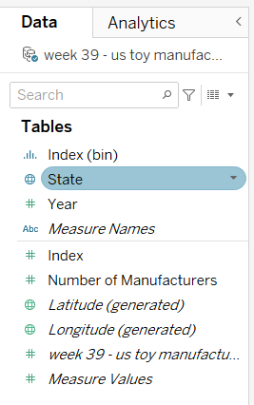
5. | Dashboard design | No of Visualizations / Graphs - 6 Visualizations  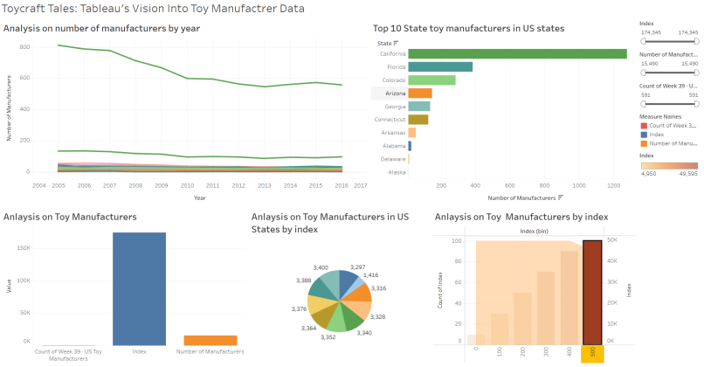
6 | Story Design | No of Visualizations / Graphs - 6 Visualizations  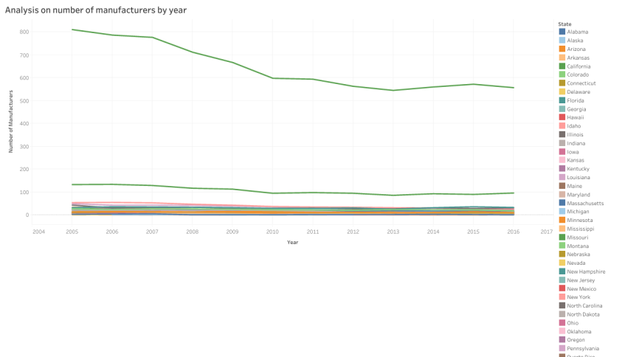  It is the story

